**Free Film Festivals website**

**Each festival has its own login. All festivals are ‘authors’ of the site, which means you can create and amend your own content but can’t amend content created by another festival.**

**If you’ve forgotten your login you can request a password reminder, which will then be emailed to you.**

**1 Creating an event page**

Click ‘Events’ in the left hand dashboard menu, then ‘Add new’. A new event page will appear.

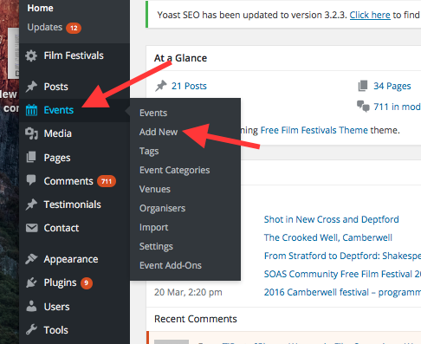

**1.1 Event title and description**

Give your event a title (generally the name of the film). Write a short one-sentence intro of around 25 words and make this bold. Write the film/event description. See existing pages for an idea of the length. Brevity is good. Aim for 200-250 words.

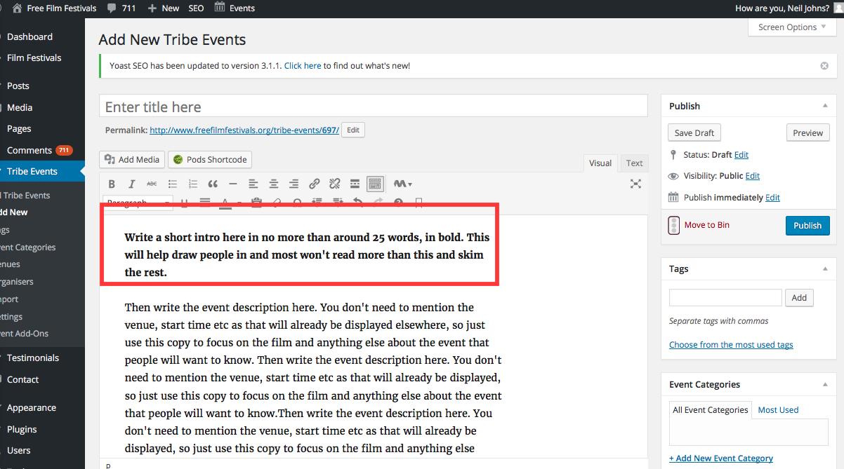

**1.2 Pasting text from Word etc**

If you’re pasting text from a doc created in another software package such as Word, click the T symbol marked below before inserting the text. This strips out all the unwanted formatting and turns your text into plain text. If you don’t do this your text might not display properly on the website.

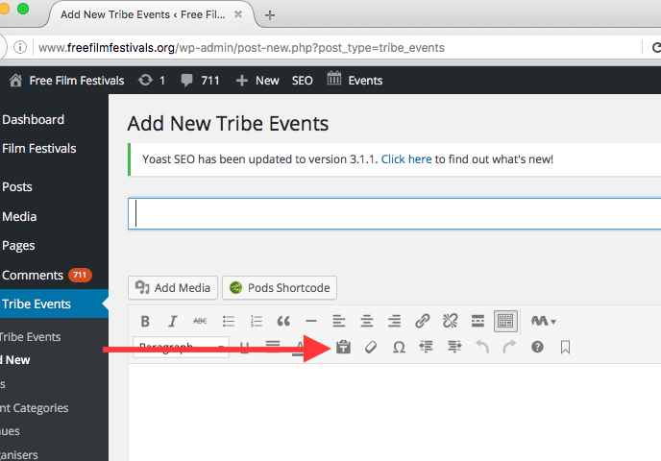

**1.3 Date and time**

Set the date and time. Make sure you select ‘pm’/’am’. By default it’s set to ‘am’ so you’ll probably need to change this. End date and time can be same as start time or just left blank.

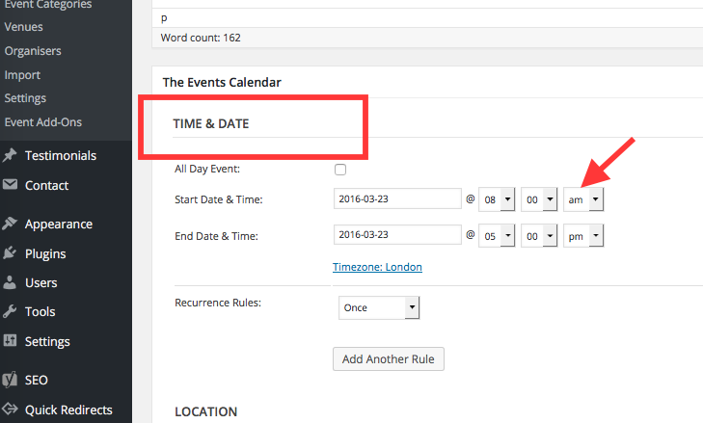

**1.4 Assigning an event to a particular festival**

In order for a new event to appear on your festival’s page, you need to tell the system which festival this event is for. Unless you do this, the event will be created but NOT appear on your festival’s page.

About half way down the right hand column is a box called ‘Film Festivals’. Start typing the name of your festival in this box and it will magically appear for you! Simply select it. This means the event you are creating will now appear on your festival’s page.

IMPORTANT! Your festival is already in the system and if you start typing its name it will appear. Do NOT type in the name again and click ‘add’ or else that creates a second festival with the same name and confuses things greatly. Simply SELECT your festival from the EXISTING list.

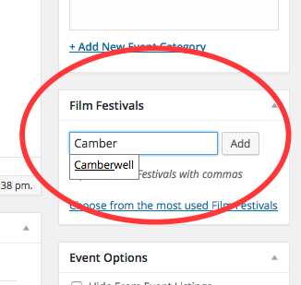

**1.5 Venue**

Venues are stored on the site so if the venue info has been added once it’s simply a case of selecting that venue. You do this by clicking ‘Use new venue’ (odd that, I think it should read ‘Use existing venue’!). You’ll see a searchable list of existing venues. If your venue is already on the system just select it.

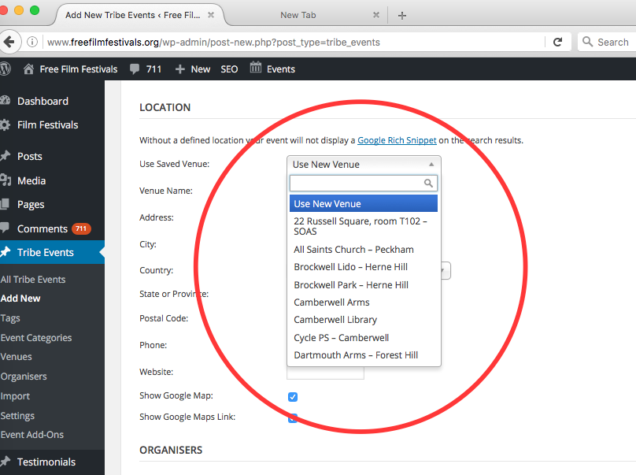

If it’s not on the system, you’ll need to enter it. The only fields that need info are name, address, city (eg London) and postcode. All other fields can be left as they are.

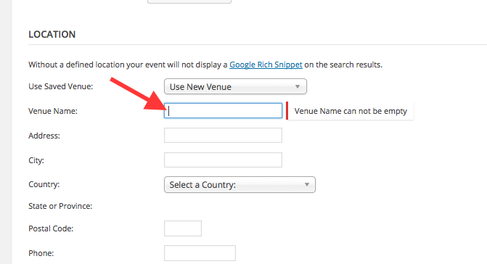

**1.6 Film details**

Add director’s name, running time etc in the boxes provide. Put time in minutes, eg 95 mins, 135 mins. You’ll need to write ‘mins’ manually.

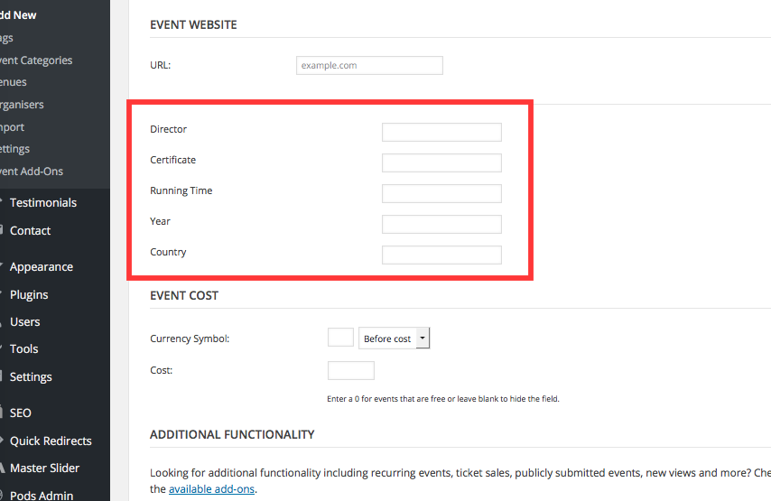

**1.7 Free event (first come, first served)**

By default, all events will have this at the top of the page in the front end, so you don’t need to do anything for this to appear on the event page, it will happen automatically..

**Free**(No ticket required - First come first served)

Occasionally, however, you might want to issue free tickets. In which case there’s a ticket module built into the site.

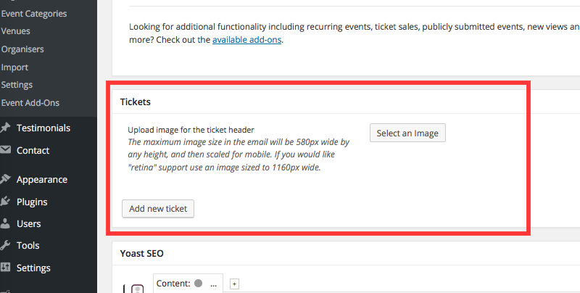

Like Eventbrite, it allows you to decide how many tickets to create for the event and communicate with all people who have obtained tickets.

**1.8 If events are NOT free**

Occasionally you might want to do events that are **not free**. For example you might want to do a **fundraising screening** and sell tickets. In this case you have the option to override the ‘Free (No ticket required…)’ setting using the ‘Hide free option’ checkbox which appears towards the bottom of the event page in the CMS. This text will then appear at the top of the page: ‘Tickets are required for this event – see below’.

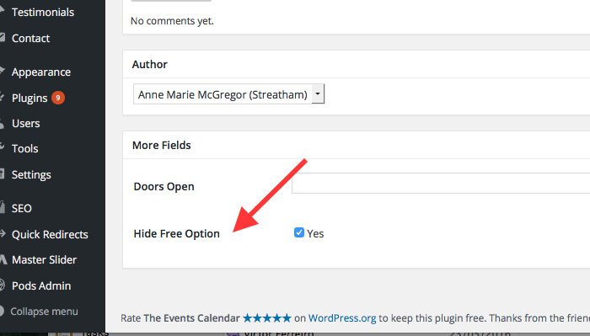

**1.9 Outdoor events**

Events will be listed as ‘indoor’ by default. If you are holding an outdoor event add the tag ‘outdoor’ in the tag box on the right hand column of the event page.

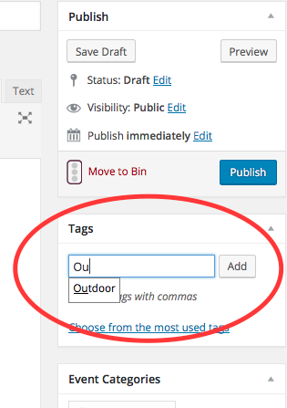

**1.10 Pictures**

You need to choose a picture to appear in the circle. You do this using the ‘Featured image’ function at the bottom of the right column. You have the option of using an image already in the media library or uploading an image to the library.

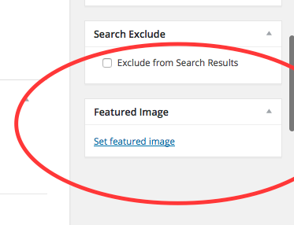

IMPORTANT: when uploading images make sure the file names match the films – eg call the file Paddington, Blues Brothers, Grease etc or something descriptive not ‘image 1’ or some random name. This is because the media library will grow and is searchable, so we need descriptive, meaningful names for the search to be useful.

Once you’ve set your featured image, you can then add the same image into the page itself (or it could be a different one but will almost always be the same one, I imagine). In order for pages to look reasonable standard I suggest we add pictures just below the intro line and on the right. Therefore, place the cursor at the start of the first para of the main copy (see where arrow is pointing) and click ‘Add media’. You need to move the cursor to the right place as that tells the system where you want the picture added.

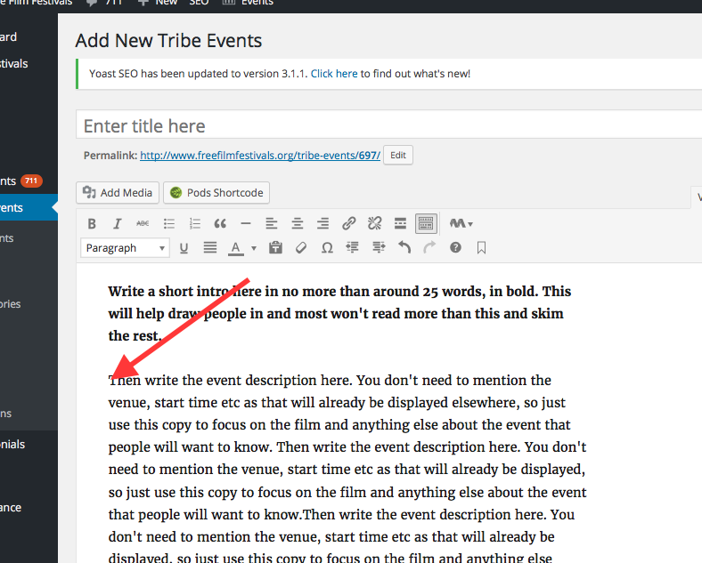

Select the picture you want inserted (or upload a new one - having given the file you are uploading a descriptive name).

If it’s not already pre-selected, choose ‘right’ for alignment, and ‘medium’ for size (see arrows in screenshot below).

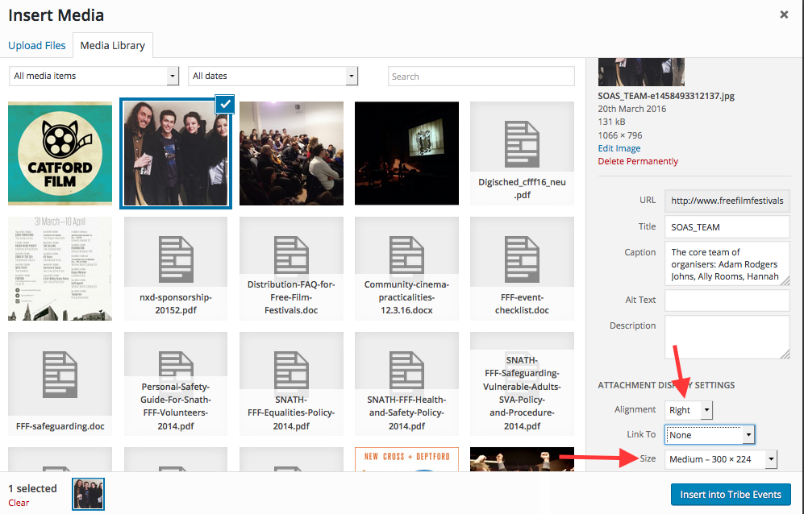

Once you’ve done all that the pic will appear in the event description looking something like this.

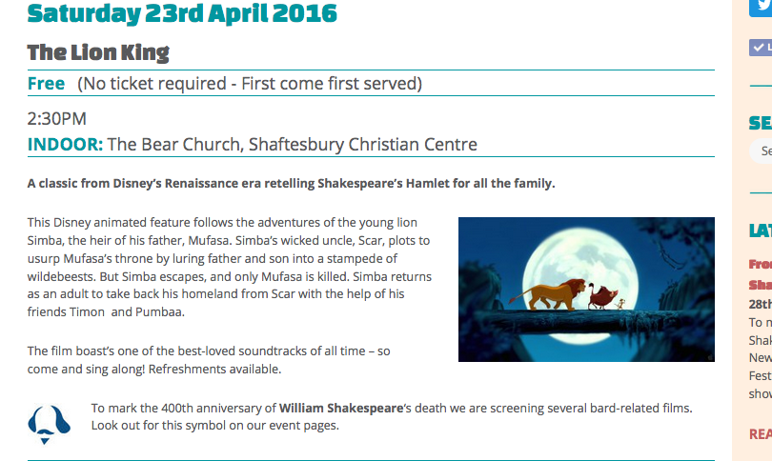

**1.11 Publish**

Once it’s ready, click ‘publish’ or ‘save draft’ to work on it later. If at any time you need to find your event in all the other events use the search facility – see arrow below.

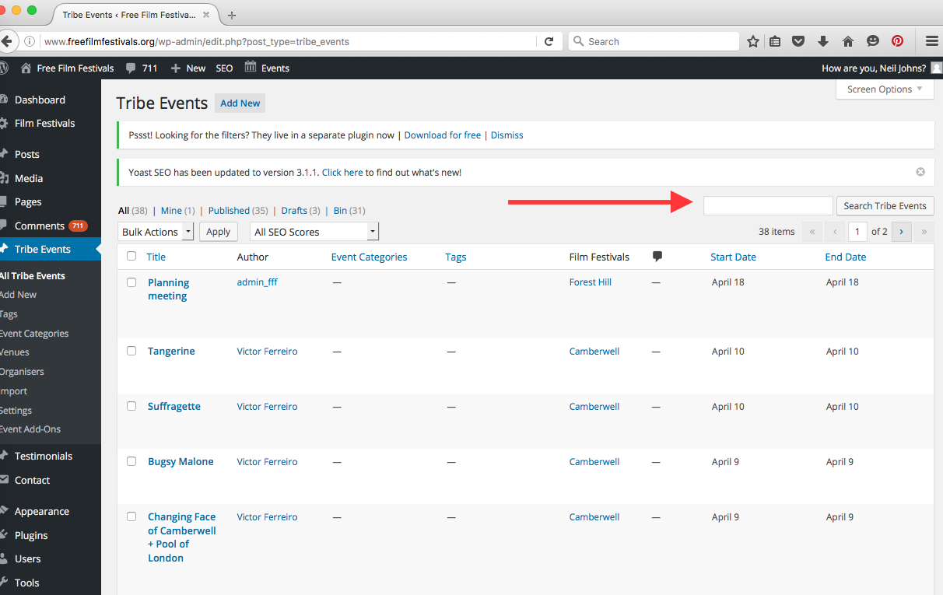

**2 Creating a blog post**

When creating a blog post, you need to click ‘Add post’ in the dashboard.

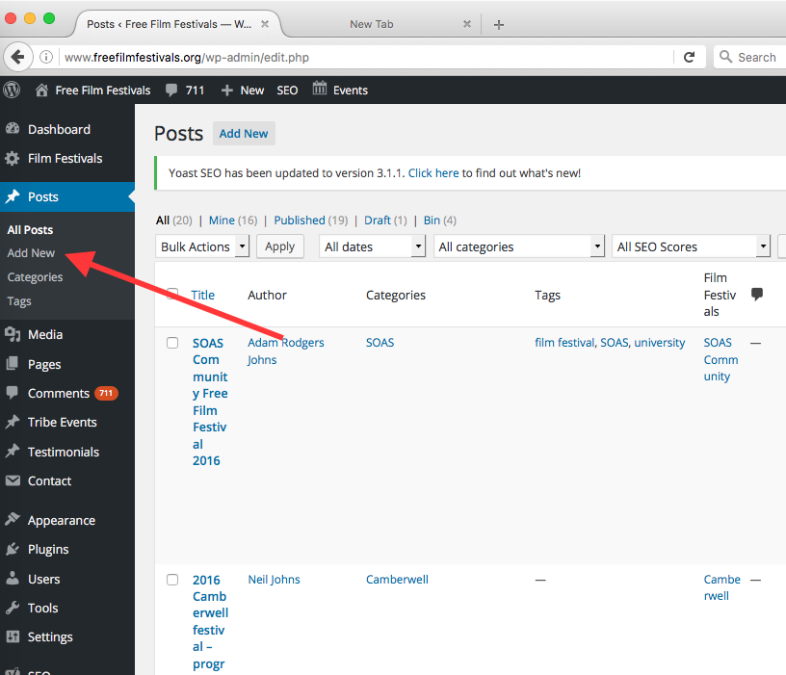

Select the name of your festival in two places. Both are in the right hand column. The first is called ‘Categories’. Simply select your festival from the list. The second is called ‘Film festivals’. If you start typing your festival into the box the name will appear.

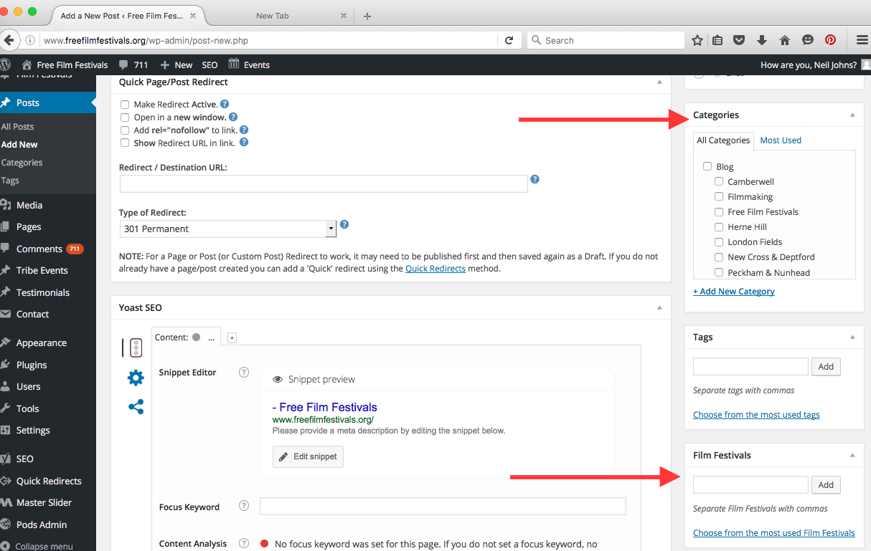

The ‘Category’ options makes sure all blog posts from your festival are grouped together in the blog. The ‘Film festival’ option means that blog post will be drawn through to your festival’s main page.

23.3.15